Lesson 5:

Jesus Heals Ten Lepers
SCRIPTURE REFERENCE:
Luke 17
MEMORY WORK:
John 3:16
PERSONAL APPLICATION:
I should always be thankful to God for everything He has done and continues to do for me.
LESSON STARTS HERE
INTRODUCTION:
God does so much for us, and He gives us so much (some big things and some little). We should be thankful for everything He does.
POINTS TO EMPHASIZE:

- Wherever Jesus went, He taught people about obeying God. He miraculously healed many people of terrible diseases and physical problems. Each miracle that Jesus performed proved that He was who He claimed to be: the Son of God.
- On one of Jesus’ trips to Jerusalem (Luke 9:51; 13:22-33), He traveled through Samaria and Galilee. In one of the villages where He stopped, ten men with a terrible skin disease called leprosy called out to Jesus for help. People with leprosy are called “lepers.”
- Leprosy was a disease for which there was no cure. Healthy people were very afraid of catching the disease and did not want to be around lepers. Lepers had to live away from their families and friends (Leviticus 13:45-46). When they came near anyone without leprosy, they covered their mouths and cried out, “Unclean, unclean!” to warn others to stay away.
- The ten lepers had heard about Jesus’ miracles. They recognized Him and begged for His help. From a distance, they called to Him loudly, asking for Him to heal them. Jesus saw them and knew immediately how much these men were suffering. The only thing Jesus said to them was, “Go and show yourselves to the priests.” Under the Old Testament law, the priests were the ones who decided if a leper was cured of the disease and could return to his family.
- These ten lonely men didn’t question Jesus at all. They immediately started toward the village to find the priests. As they were going, they were completely healed. They were healed because they believed in Jesus and obeyed His instructions. Suddenly they were healed and could return to their families! They could worship God in the temple. They could walk through the village and go to the market again without having to cover their faces, or have anyone be afraid of them.
- One of the ten men, when he realized Jesus had healed him, began to glorify (praise) God in a loud voice. He turned around and went back to thank Jesus. Jesus praised the man for his faith and asked, “Where are the nine?” Jesus was disappointed that all the men who were healed did not come back and show a thankful attitude.
- Jesus was even more impressed by this single man who returned to thank Him because the former leper was a Samaritan (from the area of Palestine called Samaria). Samaritans and Jews did not like one another, and usually had nothing to do with each other. But Jesus didn’t care where people were from. Terrible diseases, like leprosy, affected people no matter where they were from or what they believed. This one grateful Samaritan didn’t care if Jesus was a Jew. The man just wanted to thank Jesus!
- We should be thankful to God, too, for everything He has done and continues to do for us (Philippians 4:6). He has given us our families and friends, our food and clothing, our houses, the church, the Bible—and He sent Jesus to save us from our sins. We should be like the one leper who said “thank you” and not like the other nine who took Jesus’ help for granted and didn’t stop to thank Him.

RECOMMENDED ADDITIONAl VISUALS (note disclaimers):

Betty Lukens’ felt pieces
- ABeka Flash-a-Card Series (DISCLAIMER: use the cards, not the lesson book;)
- Free Bible Images – Saved on flash drive. Can be presented on classroom tv. Script included in lesson file. File will be labeled “05.”

SONGS AND FINGERPLAYS:

““I’VE GOT THE JOY, JOY, JOY, JOY DOWN IN MY HEART” (Click to Hear)
Author: Traditional
I’ve got the joy, joy, joy, joy, Down in my heart. Where? (REPEAT)
Down in my heart.
I’ve got the joy, joy, joy, joy, Down in my heart. Where? Down in my heart to stay.

I’ve got the peace that passes understanding, Down in my heart. Where? (REPEAT) Down in my heart.
I’ve got the peace that passes understanding, Down in my heart. Where?
Down in my heart to stay.

I’ve got the love of Jesus, love of Jesus, Down in my heart. Where? (REPEAT) Down in my heart.
I’ve got the love of Jesus, love of Jesus, Down in my heart. Where?
Down in my heart to stay.

SUNDAY
LEARNING CENTERS AND ACTIVITIES:
- Hand Craft (easy version) – Make copies of the hand coloring page in the lesson file. This will be a two sided copy. On the sick side, let students color the hands and put band-aids on them. On the other side, let students color the hand and place a heart sticker on only one finger.

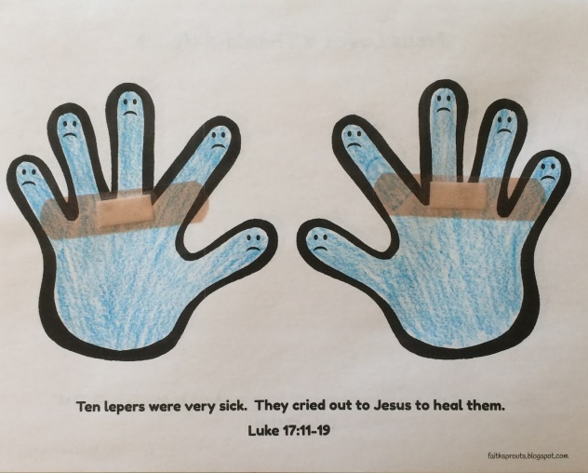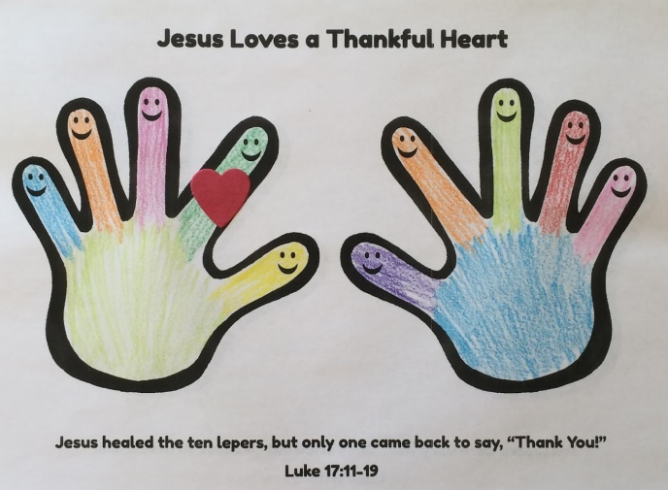

- Hand Craft (harder version) – Trace students hands on one side of paper. On left hand write “Jesus Healed.” On right hand write, “10 Men….” On the back of the paper trace a fist and a hand with one finger sticking up. On the left hand write, “…but only” and on the right, write the number “1,.” Then below the fists write “said, Thanky you.” Let the students draw faces on each of the fingers. Refer to picture below for example.

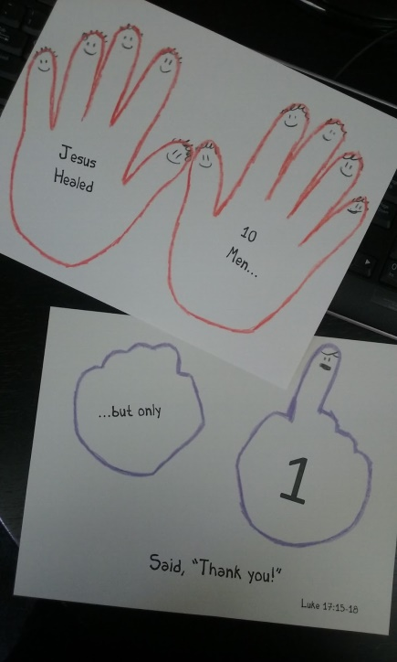

WEDNESDAY NIGHT
POINTS TO EMPHASIZE:
- Review Sunday’s lesson (see Review Questions for example questions)
LEARNING CENTERS AND ACTIVITIES:
- Help the children make a booklet or mobile of things they are thankful for.
- Show pictures (cut from magazines or personal pictures from home) of things that you are thankful for (e.g., family, house, car, food, friends, etc.).
- Have the students stand in a circle and take turns telling things for which they are thankful.
- Have the students decorate “Thank You” cards for people who do things for them (e.g., parents, teachers, elders, deacons, preacher, etc.).

Review Questions

- To what city was Jesus traveling?
  - Jerusalem

- He had to travel through what two regions?
  - Samaria and Galilee

- What disease did the ten men have that Jesus stopped to talk to?
  - Leprosy

- What were the people called who had leprosy?
  - Lepers

- Could people with leprosy live with their families?
  - No. They were considered unclean and had to live in a colony with each other since there was no cure for the disease.

- Had the ten men heard of Jesus’ miracles?
  - Yes. They called out to Him for help and healing.

- What did Jesus tell the ten men to do?
  - “Go show yourselves to the priests.”

- What happened as they were walking away from Jesus?
  - They were completely healed.

- How many came back to thank Jesus for healing him?
  - Only one

- What nationality was the man that was healed?
  - He was a Samaritan.

- How did Jesus feel about only one man coming back to thank Him?
  - He was disappointed in the other nine men.

- What should we be thankful for today?
  - Everything God has given to us and continues to give us everyday
Additional Notes / Activities Performed & Curriculum Feed Back

__________________________________________________________________________________________________________________________________________________________________________________________________________________________________________________________________________________________________________________________________________________________________________________________________________________________________________________________________________________________________________________________________________________________________________________________________________________________________________________________________________________________________________________________________________________________________________________________________________________________________________________________________________________________________________________

