Lesson 8

Listen and Obey/Wise and Foolish Builders
SCRIPTURE REFERENCE:
Matthew 7:21-27; Luke 6:46-49
MEMORY WORK:
Bible Skills 1-6
John 3:16
The 12 Apostles
PERSONAL APPLICATION:
I must do what God tells me to do in His Word—the Bible.
LESSON STARTS HERE
INTRODUCTION:
Just like our parents tell us stories, sometimes Jesus told stories to teach His lessons. His were stories that helped people obey God better.
POINTS TO EMPHASIZE:
- Jesus knew that many of the people who followed Him to hear His sermons and to see Him perform miracles would listen but would not obey His words. So, He told them a short story with a special meaning (a parable) about two men who each built a house.
- Today, when a house is built, the builder first has to make sure the ground is level. Then concrete trucks come and pour a foundation for the house to sit on. The concrete has to be leveled carefully and then allowed to dry and harden. Then, and only then, can the house be built. For big, tall buildings, sometimes the builders have to “dig deep” to have a strong enough foundation to hold the steel, bricks, and glass that the building is made of. To build a strong house, the builder must follow the blueprints (the instructions) exactly.
- In this parable, it seems that the two builders are discussed. They probably had the same materials with which to work and the same plans. Their houses would not have necessarily appeared to be different from the outside. But one house had problems, because the foundation was not what it should have been.
- The wise man “dug deep” (Luke 6:48) so that he could make a solid foundation on which to build his house. He built on the solid rock that was under the dirt and/or sand, which was as firm as concrete. But the foolish man decided to take shortcuts and built his house on unstable sand. Then a terrible storm came. The wise man’s house was safe and snug, completely unaffected by the winds and rain. But the foolish man’s house came crashing down in pieces, because it was not built on a solid rock foundation.
- Jesus used this story to teach the crowds the importance of not just hearing what He said but also obeying His words. Everything in life will go better if we build our lives on the solid foundation of God’s Word (listen to His Word and obey His instructions exactly). We can’t make up our own rules or try to do things differently than what the Bible says.

RECOMMENDED ADDITIONAL VISUALS (note disclaimers):

Betty Lukens’ felt pieces
- A Beka Flash-a-Card Series (DISCLAIMER: use the cards, not the lesson book)
- Free Bible Images – Saved on flash drive. Can be presented on classroom tv. Script included in lesson file.
- See AP’s pinterest page for ideas. www.pinterest.com/apcurriculum
- Tales of Glory Apostle Figure Set, Playmobile house with removable roof
- Props for acting out story- cake pan, house print outs, sand, rocks
SONGS AND FINGERPLAYS:

“THE WISE MAN BUILT HIS HOUSE UPON THE ROCK
Author: Ann Omley
The wise man built his house upon the rock. The wise man built his house upon the rock.
The wise man built his house upon the rock, and the rains came tumbling down.

CHORUS:
Oh! The rains came down as the floods came up.
The rains came down as the floods came up. The rains came down as the floods came up, But the wise man’s house stood firm.

But! The foolish man built his house upon the sand.
The foolish man built his house upon the sand.
The foolish man built his house upon the sand, and the rains came tumbling down.

CHORUS:
Oh! The rains came down as the floods came up.
The rains came down as the floods came up. The rains came down as the floods came up, And the foolish man’s house went splat.

So! Build your house on the Lord Jesus Christ. Build your house on the Lord Jesus Christ.
Build your house on the Lord Jesus Christ, and the blessings will come down.

CHORUS:
Oh! The blessings come down as the prayers go up.
The blessings come down as the prayers go up. The blessings come down as the prayers go up, So build your house on the Lord Jesus Christ.

“THE MORE WE READ THE BIBLE”
Author: Unknown*
(Tune: “The More We Get Together”)
The more we read the Bible, the Bible, the Bible, The more we read the Bible, the happier we’ll be. We’ll learn about Jesus and how we can please Him.
The more we read the Bible, the happier we’ll be.

“READ YOUR BIBLE AND PRAY EVERYDAY”
Author: Unknown*
If you read your Bible and pray everyday you’ll grow, grow, grow
. If you read your Bible and pray everyday you’ll grow, grow, grow.
Grow, grow, grow, grow, grow, grow, grow.
If you read your Bible and pray everyday you’ll grow, grow, grow.

If you don’t read your Bible and pray everyday you’ll shrink, shrink, shrink.
If you don’t read your Bible and pray everyday you’ll shrink, shrink, shrink.
Shrink, shrink, shrink, shrink, shrink, shrink.
If you don’t read your Bible and pray everyday you’ll shrink, shrink, shrink.

So read your Bible and pray everyday and grow, grow, grow.
So read your Bible and pray everyday and grow, grow, grow.
Grow, grow, grow, grow, grow, grow, grow.
So read your Bible and pray everyday and grow, grow, grow.

SUNDAY
LEARNING CENTERS AND ACTIVITIES:
- Houses in a Cake Pan. Laminate printouts of two basic houses. Attach the houses to craft sticks. Be sure to tape the house on the rock to the bottom of the pan so it won’t move. Stack up rocks around one house and sand around the other. Let students pour water in the pan until the house on the sand moves.
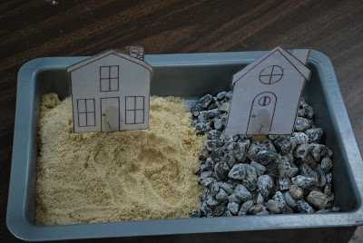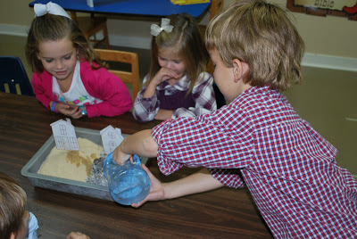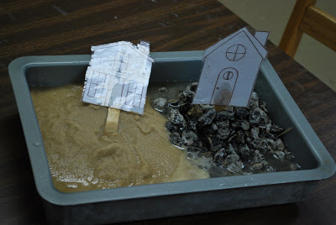

WEDNESDAY NIGHT
POINTS TO EMPHASIZE:
- Review Sunday’s lesson. (See Review Questions for example questions.)
LEARNING CENTERS AND ACTIVITIES:
- Simple Houses Craft. Give students cutouts of two simple houses. Glue one onto a rock and the other onto sand (could use yellow paper or sandpaper). Make sure the house on the sand is falling over. Clouds and rain could be added.
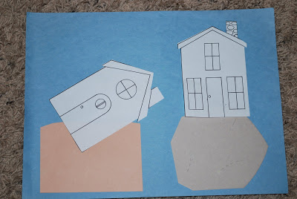

Review Questions

Does a terrible storm affect both builders?

Yes

Do both builders have the same result from their labors?

No

What was the most important thing for both builders?

The foundation on which they built

What is Jesus telling the listeners?

That they should build their lives on God’s Word

What foundation is Jesus talking about?

God’s Word

How does a person build on the foundation of God’s Word?

He must listen to it and do exactly what it says

Did people watch Jesus perform miracles and still not do what He said to do?

Yes

Why did the wise man dig deep?

To find a good foundation to build on

Is hearing the Word of God and not doing it something a wise man would do?

No

Will Jesus have mercy on a person who hears His words, but does not do them?

No

Is God’s Word as solid as a rock, spiritually speaking?

Yes

Additional Notes / Activities Performed & Curriculum Feed Back

__________________________________________________________________________________________________________________________________________________________________________________________________________________________________________________________________________________________________________________________________________________________________________________________________________________________________________________________________________________________________________________________________________________________________________________________________________________________________________________________________________________________________________________________________________________________________________________________________________________________________________________________________________________________________________________

