Lesson 2:

Jesus’ Boyhood/Visit to the Temple
SCRIPTURE REFERENCE:
Luke 2:39-52
MEMORY WORK:
Bible Skills 1-6
John 3:16
The 12 Apostles
PERSONAL APPLICATION:
With God’s help, I can grow in the same ways that Jesus did
LESSON STARTS HERE
INTRODUCTION:
Jesus was the Son of God, but He came to this Earth from Heaven and was born as the Son of Mary and Joseph. Jesus started telling others about God even when He was a boy.
POINTS TO EMPHASIZE:
- Mary and Joseph taught their children to love God and His law. Part of the Old Testament law was to observe several important feasts during the year. One of those was Passover. When Jesus was 12 years old, He went with Mary and Joseph and many other people to Jerusalem for Passover. After the seven days of the feast, Mary and Joseph started their return journey to Nazareth, thinking that Jesus was somewhere in the crowd of people traveling with them. But Jesus had stayed behind, in the temple. At the end of the first day of traveling, Mary and Joseph realized Jesus was not with the group. So they returned to Jerusalem to find Him.
NOTE: The Passover Feast was observed each year to remember the tenth plague in Egypt, when God passed over the children of Israel’s houses and killed the firstborn in the Egyptians’ houses. It was after this plague that Pharaoh allowed the children of Israel to leave Egypt (see Exodus 12).

- Imagine how worried they must have been in that big, crowded city, trying to find a 12-year-old boy. After frantically searching for Jesus for three days, they finally found Him in the temple, talking with and listening to the teachers of the Law (rabbis). Everyone there was astounded at the wisdom and insight Jesus had about God’s Word. But Mary and Joseph were more surprised and concerned that Jesus had stayed in the city—without their knowledge or permission. His worried mother asked, “Son, why have You done this to us? Look, your father and I have been looking for You. We’ve been worried sick!”
- Jesus’ reply surprised Mary and Joseph very much. “Why did you seek Me? Didn’t you know that I must be about My Father’s business?” He wasn’t being disrespectful. Jesus was talking about doing great things for His Heavenly Father, but they were so accustomed to Him being such a “normal” boy that they didn’t understand what He meant.
Rabbi: Means “teacher” or “great one.” In New Testament times, rabbis were often leaders of the synagogues and often made sure that Jewish laws were observed.
- They started back to Nazareth together, and Mary “kept all these things in her heart.” She had many things to remember and think about as Jesus grew up. He grew in wisdom: He learned and understood many things, and He learned how to use what He learned. He grew in stature: His body grew physically just like all children do. He grew in favor with God: He obeyed God and followed His Law perfectly. He grew in favor with men: Jesus learned to work with people, to talk to them and make them feel special. He had a good reputation. He also obeyed His parents (Luke 12:51), as the Scriptures taught Him (Exodus 20:12; Deuteronomy 21:18-20).
- Jesus knew He had an important job to do: to tell as many people as He could about God and to die for all men on the cross so that all men can be saved and go to Heaven. We want our bodies to grow and get stronger like His did, but we also want to grow in wisdom and in favor with God and men, as Jesus did. We have many things that we can do for God, too. Discuss things we can do to grow in all the ways Jesus did.
RECOMMENDED ADDITIONAL VISUALS (note disclaimers):

Betty Lukens’ felt pieces
- ABeka Flash-a-Card Series (DISCLAIMER: use the cards, not the lesson book;)
- Free Bible Images – Saved on flash drive. Can be presented on classroom tv. Script included in lesson file.
- Model of the Temple

SONGS AND FINGERPLAYS:

“READ YOUR BIBLE AND PRAY EVERYDAY”
Author: Unknown*
If you read your Bible and pray everyday you’ll grow, grow, grow
. If you read your Bible and pray everyday you’ll grow, grow, grow.
Grow, grow, grow, grow, grow, grow, grow.
If you read your Bible and pray everyday you’ll grow, grow, grow.

If you don’t read your Bible and pray everyday you’ll shrink, shrink, shrink.
If you don’t read your Bible and pray everyday you’ll shrink, shrink, shrink.
Shrink, shrink, shrink, shrink, shrink, shrink.
If you don’t read your Bible and pray everyday you’ll shrink, shrink, shrink.

So read your Bible and pray everyday and grow, grow, grow.
So read your Bible and pray everyday and grow, grow, grow.
Grow, grow, grow, grow, grow, grow, grow.
So read your Bible and pray everyday and grow, grow, grow.

SUNDAY
LEARNING CENTERS AND ACTIVITIES:
- Find Jesus Game . Hide a Jesus figure (could use a toy, felt figure boy, or a print out). Students should search the room to find Jesus. If you have a temple model, Jesus could be hidden in the temple.
- I Spy Jesus bottle. Make an I spy game by letting students fill small clear plastic containers (like water bottles) with rice and other small objects(confetti shapes, pony beads, foam shapes, etc.). Be sure to put a small printout of Jesus in the bottle. Be sure to hot glue the top to the bottle for the children.

WEDNESDAY NIGHT
POINTS TO EMPHASIZE:
- Review Sunday’s lesson. (See Review Questions for example questions.)
LEARNING CENTERS AND ACTIVITIES:
- Jesus coloring scroll – The coloring page for this should be in the lesson file. Make copies and trim the wide margin. Glue craft sticks to each end, then roll the paper around the sticks toward the center to make a scroll
. 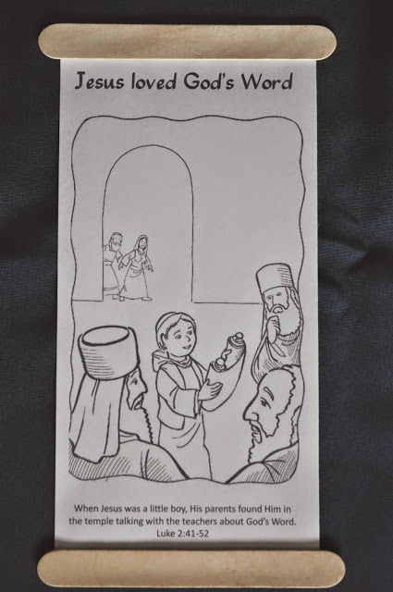

Review Questions

What book records Jesus’ childhood?

Luke

What did Joseph teach his children?

To love God and His Law

How old was Jesus when He went to Jerusalem?

12 years old

Why were Mary, Joseph, and their children going to Jerusalem?

To keep the Passover

Did Jesus stay behind in Jerusalem when His family left?

Yes

How many days did Jesus’ parents search for Him?

3 days

Where did Joseph and Mary find Jesus?

At the temple

What was Jesus doing at the temple?

Talking with rabbis

What did the rabbis think about Jesus?

They were surprised at His understanding

What is a rabbi?

Jewish teacher of the Law

Additional Notes / Activities Performed & Curriculum Feed Back

__________________________________________________________________________________________________________________________________________________________________________________________________________________________________________________________________________________________________________________________________________________________________________________________________________________________________________________________________________________________________________________________________________________________________________________________________________________________________________________________________________________________________________________________________________________________________________________________________________________________________________________________________________________________________________________

