Lesson 9:

Belshazzar’s Feast

SCRIPTURE REFERENCE:
Daniel 5

MEMORY WORK:
Bible skills 1-6 Psalms 119:105
PERSONAL APPLICATION:
I must remember that God gave me every blessing and talent that I have. God does not want me to be a “show off” or brag.
LESSON STARTS HERE
INTRODUCTION:
Review last week’s lesson.
God helped Daniel understand dreams and visions. In today’s lesson, the king was having a party and something very strange happened. Let’s see what happened and how Daniel was able to help.

POINTS TO EMPHASIZE:

- Belshazzar, the king of the enormous Babylonian Empire, decided to have an elaborate feast in his palace for a thousand of his nobles (officials who were loyal to him) and his wives. There was a great deal of drinking alcohol at this wild party. [Commentators generally regard this feast as a “drunken orgy.”]
- To show off to his guests, Belshazzar ordered that all the gold vessels that had been taken from the Temple in Jerusalem by Nebuchadnezzar many years before be brought to the party. They drank wine from the golden cups that had once been used in worship to God, and they praised their gods as they drank and drank.
- Suddenly, in the midst of the loud partying, “the fingers of a man’s hand” appeared and began writing on a plaster wall in the room where these people were gathered. The back of the hand was toward Belshazzar, and he was scared to death (note verse six). Neither the king nor any of his guests had ever seen anything like that before. Everyone was terrified!

- Belshazzar called his wise men to come and tell him what the appearance of the hand and the strange words on the wall meant. But none of the wise men or magicians could interpret the message. This made the king even more frightened (Daniel 5:9). The Queen Mother (ESV; probably a daughter of Nebuchadnezzar) came into the room to see what the commotion was all about. She reminded the king that there was a man in the kingdom who had helped Nebuchadnezzar understand dreams and other things that Babylonian wise men could not understand. She told Belshazzar that he should talk to this man whose name was Daniel.
- Daniel was brought to the king to help. Belshazzar promised him a gold necklace, the clothing of royalty, and the position of being third in command of all the empire if he would interpret the writing on the wall. Daniel told the king that he did not need gifts; he would help the king without any reward at all.
- Daniel reminded Belshazzar that Nebuchadnezzar had been very proud and haughty about his great empire, and God had punished him for his arrogance and for his faith in false gods. [Tell the older children about Nebuchadnezzar’s time living as an animal in the field (Daniel 4:28- 37).] Belshazzar knew about this terrible time in Nebuchadnezzar’s life, yet refused to learn from it (Daniel 5:22).
- Daniel said that the hand was sent from God and that the message was miraculously from God. It was not a magic trick or something that one of the idols of the Babylonians could do. The inscription (mysterious message) on the wall was “MENE, MENE, TEKEL, UPHARSIN.” MENE meant that God was about to bring Belshazzar’s kingdom to an end. TEKEL meant that the king had been judged as unfaithful to the Ultimate Judge. UPHARSIN (or PERES) meant that the Babylonian empire would be taken over by the Medes and Persians.
- Even though Belshazzar was very frightened by Daniel’s message, he kept his promise to Daniel and gave him a golden necklace, the clothing of royalty, and declared him to be the third in command in the empire.
- That very night, the Medo-Persian army, led by Darius the Mede, conquered Babylon. [They were evidently attacking while Belshazzar was having the wild party.] The Persian army killed Belshazzar that same night.
- God punished Belshazzar because of his great pride and his disrespect (Daniel 5:22-23). Belshazzar was self-centered and unwilling to give others or God credit for the good things that happened to him. This kind of pride means bragging about what we have done or about what we have. If I have sinful pride, I can make other people feel less important. We must remember that God made us and has given each of us the abilities and blessings that we have; we must never forget where they came from. [Illustrate this point by reminding the children how hard their parents work to provide them with food, clothing, etc., how selfish and disrespectful it is when children expect more and more but don’t show gratitude, etc. How do parents feel when they are treated this way? How do children feel when other kids treat them this way?]

RECOMMENDED ADDITIONAL VISUALS (note disclaimers):

Free Bible Images on Flashdrive. Pictures may be presented on classroom tv.

Betty Lukens’ felt pieces

Daniel ABeka Flash-A-Card Series (DISCLAIMERS: use the cards, not the lesson book)

Bible Study Guide for All Ages (BSGFAA) Lesson 19. These visuals will look like a black and white comic strip on one large piece of cardstock. To use these attach it to the magnetic dry erase board. Use dry erase markers to follow the directions. Let students take turns marking on the page.

SONGS AND FINGERPLAYS :

Prophet SUNDAY
LEARNING CENTERS AND ACTIVITIES:
- Handwriting on the Wall Magical appearing Activity – Make copies for each student of the picture of the king and the wall. Use the sheet with the words MENE MENE TEKEL PARSIN for tracing. Trace the words with a white crayon in the box of the student pages. Give each student their copies. When you get to the part of the lesson where the hand appears, let student color the wall (the box) with a crayon. As they color the wall the words magically appear.
Bibleclasscreations.blogspot.com “Handwriting on the wall craft”

.
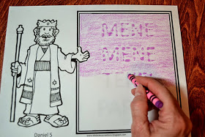

WEDNESDAY NIGHT

POINTS TO EMPHASIZE:
- Review Sunday’s lesson. (See Review Questions for example questions.)

LEARNING CENTERS AND ACTIVITIES:

- “Proud or Humble” game: Describe situations in which children (or adults) act proud and humble, or have pictures to illustrate prideful behavior. Have the children decide if the person in the scenario is proud or not. Proud and Humble Scenarios” provided in activity sheets)
- Bring two different kinds of candy or fruit. Compare how they are different and how
they are the same. Talk about how it is easy for us to look at others and try to compare ourselves to someone else. Talk about how God does not want us to compare ourselves to others.
- Let the children act out the story. Let one of them wear a glove to represent the “hand.”

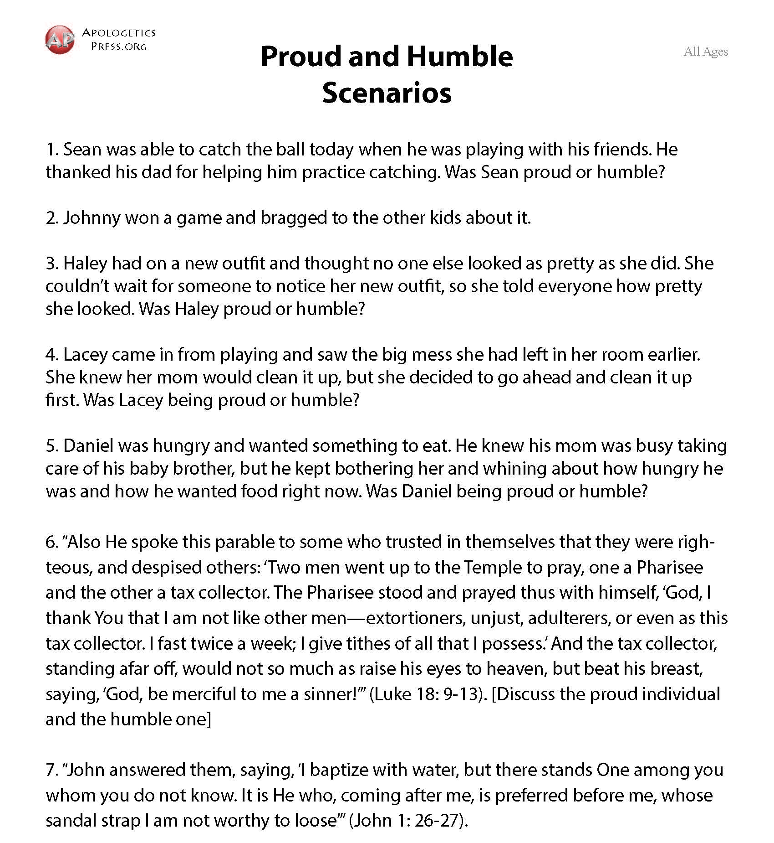

Review Questions

- Who was Belshazzar??
  - The king of the Babylonian Empire

- To show off to his guests, what did Belshazzar bring to the party?
  - All of the golden vessels that had been taken from the Temple in Jerusalem by Nebuchadnezzar

- What happened in the middle of this wild party?
  - The fingers of a man’s hand appeared, and began writing on a plaster wall in the room where the guests were gathered.

- How did Belshazzar react to what happened?
  - He was very afraid.

- Who did Belshazzar first consult to find out what the hand and strange words meant?
  - His wise men and magicians

- Could the wise men and magicians help Belshazzar?
  - No

- Of whom did the Queen Mother remind Belshazzar?
  - Daniel, who had helped Nebuchadnezzar

- If he could interpret the writing on the wall, what did Belshazzar promise Daniel?
  - A golden necklace, the clothing of royalty, and the position of being third in command of all the empire

- How were the words written on the wall interpreted by Daniel?
  - He said that it meant that God was about to bring Belshazzar’s kingdom to an end; the king had been judged as unfaithful to the Ultimate Judge; and that the Babylonian empire would be taken over by the Medes and Persians.

- What happened later on that same night?
  - The Medo-Persian army, led by Darius the Mede, conquered Babylon and the Persian army killed Belshazzar.

Additional Notes / Activities Performed & Curriculum Feed Back

__________________________________________________________________________________________________________________________________________________________________________________________________________________________________________________________________________________________________________________________________________________________________________________________________________________________________________________________________________________________________________________________________________________________________________________________________________________________________________________________________________________________________________________________________________________________________________________________________________________________________________________________________________________________________________________

