Lesson 8:

Nebuchadnezer’s Dream About a Tree

SCRIPTURE REFERENCE:
Daniel 4

MEMORY WORK:
Bible skills 1-6 Psalms 119:105
PERSONAL APPLICATION:
No matter how important we are, God is greater and more powerful than any man.
LESSON STARTS HERE

INTRODUCTION:
Who was the king that took the Jews captive and put Shadrach, Meshach, and Abednego in a fiery furnace? Nebuchadnezer. Did he worship God? No. Today we are going to learn how God punished him.

POINTS TO EMPHASIZE:

- Even though King Nebuchadnezzar praised the God of Shadrach, Meshach, and Abednego in Daniel 3:27-28, he continued to insist that everyone show him respect and honor. He did not give up his own pride.
- In Daniel 4, we read that he had another disturbing dream, and Daniel was called to interpret it. Daniel was very disturbed by the dream and encouraged the king to change his life (Daniel 4:27). But 12 months later, Nebuchadnezzar walked on the roof of his palace and claimed all the success of his kingdom as his own. Immediately, he lost his mind and became like an animal, just as the dream had predicted.
- While there is some dispute about the meaning of “seven times” (4:16,23,25,32), it is very possible that the most powerful king in the world at that time lived in the fields like an animal for seven years! What was the solution—the way for him to return to his life as king? He had to repent of his great pride.
- Discuss the meaning of pride and the dangers of pride with the kids.

RECOMMENDED ADDITIONAL VISUALS (note disclaimers):

Betty Lukens’ felt pieces
- Daniel ABeka Flash-a-Card Series (DISCLAIMER: use the cards, not the lesson book;)
- Free Bible Images saved on flash drive. Suggested script is in lesson file.

Bible Study Guide for All Ages (BSGFAA) Lesson 18. These visuals will look like a black and white comic strip on one large piece of cardstock. To use these attach it to the magnetic dry erase board. Use dry erase markers to follow the directions. Let students take turns marking on the page.

SONGS AND FINGERPLAYS :

Prophet SUNDAY
LEARNING CENTERS AND ACTIVITIES:
- Draw the dream – Draw a picture of the tree as Nebuchadnezzer saw it in his dream. Then draw a second picture of the dream after the tree was cut down. The example below is another option. Have students tell you what the dream meant. This activity could also be done with playdoh
- 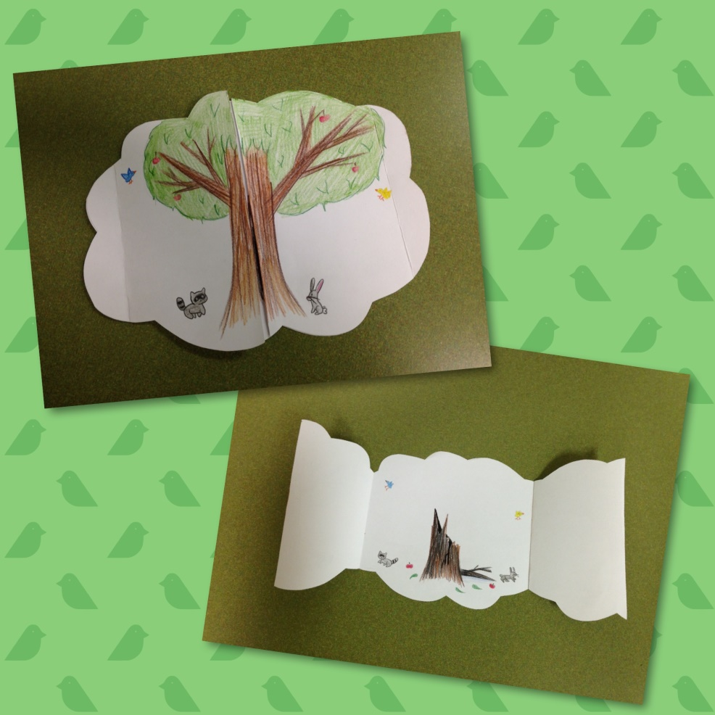

WEDNESDAY NIGHT

POINTS TO EMPHASIZE:
- Review Sunday’s lesson. (See Review Questions for example questions.)

LEARNING CENTERS AND ACTIVITIES:
- This is a fairly short lesson and would be a good night to do a general review or work on memory work.

Review Questions

- What caused King Nebuchadnezzar to be afraid?
    - He had a dream
- What were some things you remember in Nebuchadnezzar’s dream?
    - Allow different responses
- Who was able to tell the king his dream?
    - Daniel
- What advice did Daniel give the king after he told him what the dream meant?
    - Turn away from sins, do what is right, be kind to the oppressed
- When did King Nebuchadnezzar’s dream come true?
    - 1 year later
- How long did Nebuchadnezzar live like a wild animal?
    - 7 years
- Who did Nebuchadnezzar finally acknowledge as the Ruler over all?
    - God

Additional Notes / Activities Performed & Curriculum Feed Back

__________________________________________________________________________________________________________________________________________________________________________________________________________________________________________________________________________________________________________________________________________________________________________________________________________________________________________________________________________________________________________________________________________________________________________________________________________________________________________________________________________________________________________________________________________________________________________________________________________________________________________________________________________________________________________________

