Lesson 13:

Jacob Deceives His Father/Jacob’s Dream
SCRIPTURE REFERENCE:
Genesis 27,28
MEMORY WORK:
Genesis 1:1
Days of Creation
PERSONAL APPLICATION:
When we make bad choices, there will always be bad consequences.
LESSON STARTS HERE
INTRODUCTION:
Last week we studied about Isaac and Rebekah having twin boys. Do you remember their names? (Jacob and Esau) Today we will talk about a bad decision that Jacob made which hurt his whole family.
POINTS TO EMPHASIZE:
    - Review last week’s lesson on Esau selling his birthright to Jacob for a bowl of stew, and how
selfish both brothers were.
    - Sometime after Esau sold his birthright to Jacob, Isaac asked Esau to go hunting for him. Isaac was very old, and he was blind. He may have been expecting to die sometime in the near future because he asked Esau to do him a special favor: go hunting and come back home to prepare his favorite food. Isaac promised to give Esau the final blessing as the oldest son after Esau did this favor for him.
    - Rebekah was listening to this conversation and decided that her favorite son, Jacob, should receive his father’s blessing instead of Esau. She told Jacob what she had heard and told him that she had a plan to help him get Isaac’s blessing instead of Esau. Rebekah wanted Jacob to pretend to be Esau and trick Isaac, to lie to his own father.
    - God had already promised that the older son (Esau) would serve the younger (Jacob) (Genesis 25:23), speaking of the descendants of Jacob and Esau. Instead of praying to God for guidance, Rebekah wasn’t paying attention to God’s promises. She rushed to “handle things” on her own.
    - Jacob did not want to follow his mother’s instructions because he was afraid that Isaac would curse him instead of bless him. Jacob also knew that Esau would be very angry with him for taking something else away that rightfully belonged to him as the oldest son. But Jacob decided to follow his mother’s instructions anyway and lie to his own father.
    - Rebekah prepared the special meat dish that Isaac liked while Esau was gone. When Jacob took the food to his father, Isaac knew right away that the voice was not the voice of Esau. But Jacob lied and said he was Esau. In fact, Jacob did many things to deceive his father and make Isaac think he was Esau. He put on some of Esau’s clothes. He even covered his arms and the back of his neck with animal skins so that he would seem to be hairy like Esau. Isaac touched Jacob’s neck and arms and asked Jacob to come close so he could smell Esau’s clothes. With all of his tricks, Jacob convinced his father that he really was Esau. So, Isaac gave Jacob the blessing that was intended for Esau.
    - The blessing or curse of the father for his children was like a prayer to God on their behalf. Whatever the father said about their future was expected to happen. Isaac’s blessing on Jacob was that he would have good crops and big herds of animals (and therefore wealth), people of other nations would bow down to him, and that he would be master over his brother (i.e., his brother would someday serve him).
    - Almost as soon as Isaac had spoken the blessing to Jacob, Esau returned from hunting. He prepared the special dish Isaac had asked for and took it to him. Immediately Isaac knew he had been tricked, and he was so upset that he trembled! He explained to Esau what had happened. Esau was very angry and so upset that he cried (Hebrews 12:17). He decided that when his father died, he would kill Jacob and take back the birthright and the blessing that Jacob had taken from him.
    - Rebekah found out that Esau was planning to kill Jacob, so she told Jacob to go to her brother Laban, far away from home. She convinced Isaac that Jacob should go back to her family to find a wife.
    - Rebekah and Jacob made some very bad choices that had terrible consequences. Both parents were hurt, and the family fell apart. Jacob never saw his mother again; she died while he was gone. Because he was so angry, Esau made some bad decisions just to hurt his parents. His descendants would be enemies of Jacob’s descendants for hundreds of years. [Esau married three women from among the idol-worshipping people of Canaan (Genesis 28:8-9).]
    - Other people sometimes have things that are nicer or better or bigger than what we have. But God does not want us to covet what other people have (to want their things or the same things so badly that we will do almost anything to have them). God expects us to work for, and be grateful for, what we have—not to want what other people have. Sometimes people covet so many things that they are even willing to hurt other people or steal from them. That is not only disobeying God, it is choosing not to treat others like you want to be treated.

The name “Jacob” means deceiver; supplanter; heel catcher.

RECOMMENDED ADDITIONAL VISUALS (note disclaimers):

Betty Lukens’ felt pieces
- ABeka Flash-a-Card Series (DISCLAIMER: use the cards, not the lesson book)
- Free Bible Images – Saved on flash drive. Can be presented on classroom tv. Script included in lesson file.
- See AP’s pinterest page for ideas. www.pinterest.com/apcurriculum
- Act out the story with props – tent, fake fur, bowls and play food
SONGS AND FINGERPLAYS:
“3 Wandering Jews”

Once there were 3 wandering Jews (repeat)
Wandering, wandering, Jew-Jew-Jews (repeat)
Once there were 3 wandering Jews.

The first one’s name was Abraham (repeat)
Abra-Abra-ham-ham-ham (repeat)
The first one’s name was Abraham

The second one’s name was Isaac (repeat)
I-I-saac-saac-saac, (repeat)
The second one’s name was Isaac

The third one’s name was Jacob(repeat)
Ja-Ja-cob-cob-cob, (repeat)
The third one’s name was Jacob.

The all went down to Canaan land, (repeat)
Canaan, Canaan, land, land, land, (repeat)
They all went down to Canaan land.

SUNDAY
LEARNING CENTERS AND ACTIVITIES:
- Provide child-sized robes so the children can dress up like the four characters in this story. You could also provide fake fur for “Jacob’s” arms, a bow and arrow for “Esau,” a large pot for cooking the special meal.
- Make furry arms – Fake fur is available at craft stores such as Hobby Lobby or JoAnn’s and sometimes Walmart. A cheaper alternative is to glue yarn onto craft foam. Then thread yarn through the “fur” to tie around the arms.

WEDNESDAY NIGHT
POINTS TO EMPHASIZE:
      - Review Sunday morning lesson (see Review Questions for example questions)
      - Esau was very angry with Jacob for lying to their father and getting the blessing that was supposed to be his, along with the birthright. He said that he would kill Jacob after their father died. To protect Jacob, Rebekah decided that he should go far away to where her family lived.
      - She told Isaac that Jacob needed to go away to find a wife. Isaac agreed and sent him to Rebekah’s home country, Paddan-aram. Rebekah did not plan on Jacob being gone 20 years though. As far as we know, Jacob never saw his mother again.
      - Jacob left Beersheba and started on the long journey to Haran. One night during this journey, he stopped after sundown and found a place to rest. The place where he stopped was one of the places his grandfather Abraham had built an altar to God many years before on his journey from Ur to Canaan. The place was called Bethel (or Luz). Using a stone for a pillow, Jacob went to sleep.
      - During the night Jacob had a wonderful dream. This was not a dream like you and I have, nor was it his imagination. It was God’s way of speaking to Jacob and giving him a very special message. He saw a ladder reaching up to heaven, with angels going up and down on it. God spoke to Jacob, telling him the same promises that He had made to Abraham and to Isaac:
        - I will give the land of Canaan to you and to your descendants.
        - Your descendants shall be like the dust of the Earth.
        - Through your descendants all people of the Earth will be blessed.
        - I will always be with you.
      - When Jacob woke up, he was afraid because he knew that God Himself had spoken to him. He took the stone that had been his pillow during the night and set it up as a pillar (a special marker) to remind him later what a special place this was. Jacob worshipped God there at Bethel (which means “house of God”) and promised that, from that time on, he would give one tenth of everything he had to God.
LEARNING CENTERS AND ACTIVITIES:
- Jacob’s Ladder game: Divide the class into teams or let the class play as a whole. Make an angel out of a die cut or laminate a picture of one. (Two if you have divided the class into teams) and attach a magnet to the back., Draw a ladder on the dry erase board. Ask a review question. If the team gets an answer correct move the angel up the ladder. The first team to reach Heaven wins.

Review Questions
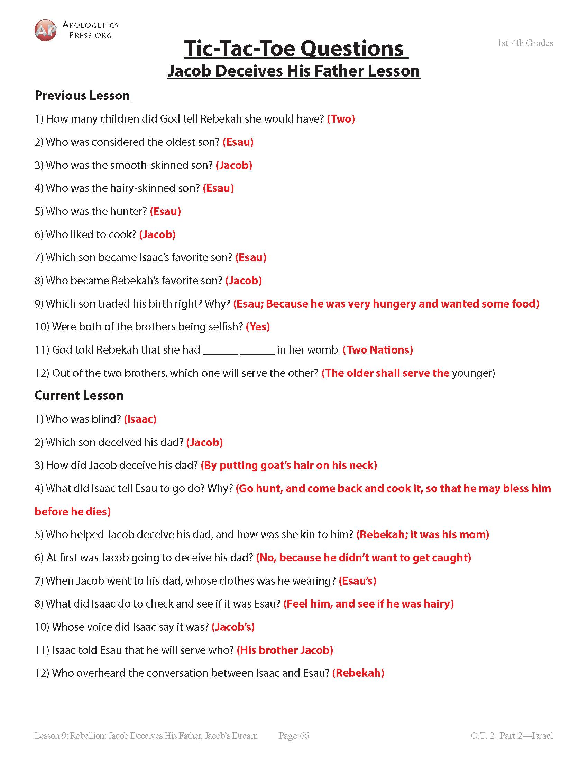

Additional Notes / Activities Performed & Curriculum Feed Back

________________________________________________________________________________________________________________________________________________________________________________________________________________________________________________________________________________________________________________________________________________________________________________________________________________________________________________________________________________________________________________________________________________________________________________________________________________________________________________________________________________________________________________________________________________________________________________________________________________________________________________________________________

