Lesson 1:

Saul Chosen First King of Israel
SCRIPTURE REFERENCE:
1 Samuel 7:17-12:25
MEMORY WORK:
Psalm 23:1 The Lord is my shepherd; I shall not want.
PERSONAL APPLICATION:
I must be careful not to let anything or anyone be as important to me as God.
LESSON STARTS HERE
INTRODUCTION:
What does a king do? He has to make decisions, and he tells people what to do, etc. We don’t have a king in our country. During the time of the judges, the Israelites didn’t have a king like the other nations around them, and they wanted one so they could be like everybody else. How do you think God felt about that?
POINTS TO EMPHASIZE:
- As a judge and a prophet, Samuel was the main leader of the Israelites. He spoke God’s words to the Israelites so they would know how God wanted them to live, and so they would worship God as He commanded. Samuel tried to be a good example for the Israelites. They would go to Ramah where he lived to ask him for help and advice, and he traveled from place to place to help them as well.
- Remember that God spoke to Samuel the first time when he was just a boy. As Samuel grew older, he married and, like Eli, had two sons. Samuel appointed his sons to help him lead the Israelites, but just like Eli’s sons, Samuel’s sons grew up to become wicked and dishonest men. The older men (the leaders) of the Israelites came to Samuel and told him they did not trust his sons to lead them after he died. They demanded a king.
- The Israelites did not want Samuel’s sons to be their leaders because of their wickedness and dishonesty, but they mainly wanted a king because they wanted to be “like all the nations” (1 Samuel 8:5). They wanted to “be like everybody else” instead of being the set apart (i.e., holy) people God expected them to be. [The Israelite leaders claimed that they wanted to have a leader that could give them more protection—a feeling of security—than the judges (i.e., that would “go out before [them] and fight [their] battles—1 Samuel 8:20). But the judges had God’s might behind them. The real reason for the request was, as already stated, just to be like everyone else.]
- Samuel was very upset by the people’s request for a king because it showed their lack of faith in God and the leaders He chose for them. Samuel probably felt rejected by the people, as though his leadership as a judge had not been enough for them. So Samuel did what he always did when he had a difficult decision to make: he prayed to God for guidance. God told Samuel that they were not rejecting Samuel. They were rejecting God Himself, Who was already their true King (1 Samuel 8:7).
- God told Samuel to warn the people that a king will oftentimes make decisions that would make their lives harder, not better. Then after the warning, when the Israelites still demanded a king, God told Samuel to give them one. (Moses also warned them in Deuteronomy 17:14-20 about wanting a king in the Promised Land.)

NOTE: One commentator calls this “God’s permissive will,” giving them what they asked for and allowing them to suffer the consequences.
- God told Samuel what man to choose for Israel’s first king. The first king was chosen from the tribe of Benjamin. The man’s name was Saul, the son of Kish. He was taller than any of the people and very handsome. Samuel anointed him privately. God gave Saul the temporary ability to prophesy so that other people would recognize that he was chosen by God. (Note Saul’s reluctance and the three signs given to him in chapter 10.)
- Saul was very tall and handsome, but he did not have a strong character. Samuel, on the other hand, was godly, completely obedient, and willing to serve God—no matter what. Read 1 Samuel 16:7.
Anointed: poured oil over Saul’s head as a sign that he was chosen by God
- A week after the anointing, the people were told to come together so that Samuel could tell them Saul was their first king. Not long after that, the Ammonites threatened to attack the Israelites. Saul’s first act as King of Israel was to bring all twelve tribes together as a great army (chapter 11) to fight a common enemy. The Israelites won a great victory! [Saul was appointed king, in front of the Israelites, at Gilgal (1 Samuel 11:15).]
- Chapter 12 is Samuel’s final major speech to the people. Just as Moses did before his death, Samuel reminded them to obey God Who had provided for them and protected them since their ancestors left Egypt many years before. All the people repented and agreed to obey God. They asked Samuel to pray for them. Samuel was happy to pray for the people, but he made it very clear that if they decided to disobey God again, they and their new king would suffer the consequences (be punished).
- The key verses in this story are 8:7 and 12:20-24. The Israelites had decided to make someone other than God first in their lives: someone physical instead of spiritual, someone imperfect rather than the all-powerful and perfect God. The danger for us is the same as it was for the Israelites. We can choose to give our love, attention, respect, and honor to other people or to things or to activities we hurt God very much.
- While we do not worship wooden or golden images that we buy or make, we can still have idols. What can become our idols? An idol can be anything or anyone that is more important to us than God. When other things or people become our idols, we gradually ignore what God says is right and wrong (read Matthew 6:24; Ephesians 5:5; Colossians 3:5; Deuteronomy 10:17,20,21; 6:4).

RECOMMENDED ADDITIONAL VISUALS (note disclaimers):

Betty Lukens’ felt pieces, Lesson 37 in Betty Lukens Manual
- ABeka Flash-a-Card Series Life of Samuel (DISCLAIMER: use the cards, not the lesson book;)
- Free Bible Images – Saved on flash drive. Can be presented on classroom tv. Script included in lesson file. File will be labeled “01” in the Visuals Folder
- Columns from the cake section can be used to make a throne room for a king toy
- Bulletin Board Idea : Pictures of three kings of Israel with descriptions of each. This could be adapted into a game. Put all the pieces on magnets or lay pictures of the kings on the table and let the students match the characteristcs to the correct king.
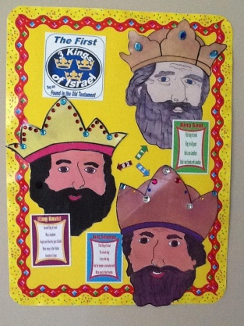

SONGS AND FINGERPLAYS:

“Anointing King Saul”
Author: Jeff Miller
(Tune: “Zacchaeus Was A Wee Little Man”)

Once there was a really tall man, yes, A really tall man was he.
A handsome man of Benjamin, Saul sought his dad’s donkeys.
He came to Zuph to Samuel, God’s prophet brave and true.
And Samuel,
Took a flask of oil,
And anointed Saul the first king, And anointed Saul the first king

SUNDAY
LEARNING CENTERS AND ACTIVITIES:
- Tall Saul. The Bible says Saul was a head taller than the other men. Mark the students height on a large piece of bulletin board paper. Then draw a person a head taller than the tallest person.
- Make crowns using template and cardstock or blank crowns available through oriental trading. Crowns can be decorated with crayons, markers, stick on jewels, stickers, etc.

WEDNESDAY NIGHT
POINTS TO EMPHASIZE:
- Review Sunday’s lesson. briefly (See Review Questions for example questions.)
LEARNING CENTERS AND ACTIVITIES:
- Hide King Saul -Just like King Saul hid among the baggage, hide a King Saul (picture, felt person, little people figure etc.) and have the children search for him. Or as a review, hide all the felt pieces for the story around the room. When the students find all the pieces, let them retell the story using those pieces. See the Betty Lukens Manual for guide.
- Introduce King Facts Review Game - Decorate three Kleenex boxes or shoe boxes with slots in the top for the 3 kings of the United Kingdom of Israel (Saul, David, Solomon). Have laminated cards with descriptions of each king. Introduce the facts that go along with King Saul. As you study the other kings add new facts. This can be used as a review game – adding new cards all quarter. The picture below is an example. You could also have 3 pictures of kings and have the students place the cards under the kings on the table. The facts for king Saul this week could include:
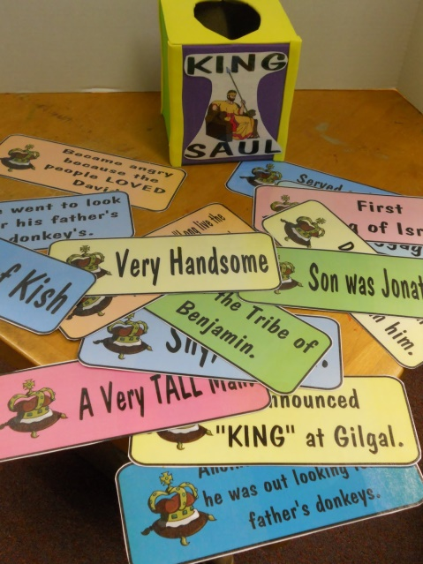
  - First King of Israel
  - Shy, at first
  - Very Tall

Review Questions

- Where did Samuel live?
  - Ramah

- How many sons did Samuel have
  - Two

- Did Samuel’s son’s serve God?
  - No, the were known as wicked and dishonest men

- Did the Israelites want Samuel’s sons to lead them after Samuel?
  - No

- What did the Israelites want that other nations had?
  - A King

- Why did the Israelites want a king?
  - They wanted to be like everybody else and not set apart as holy people of God.

- How did Samuel respond to their request?
  - He was very upset, but he still went to God in prayer for guidance

- What was God’s response?
  - Although God was not pleased, he told Samuel to appoint a king.

- Whom did God choose to be king?
  - Saul, the son of Kish, from the tribe of Benjamin

- What did Samuel tell the Israelites in his final speech?
  - Obey God. He reminded them that God had provided for them and protected them since their ancestors left Egypt.

Additional Notes / Activities Performed & Curriculum Feed Back

__________________________________________________________________________________________________________________________________________________________________________________________________________________________________________________________________________________________________________________________________________________________________________________________________________________________________________________________________________________________________________________________________________________________________________________________________________________________________________________________________________________________________________________________________________________________________________________________________________________________________________________________________________________________________________________

