Lesson 4:

The 12 Spies
SCRIPTURE REFERENCE:
Numbers 13 and 14; Deuteronomy 1:19-46
MEMORY WORK:
Joshua 1:9
PERSONAL APPLICATION:
God can help me overcome problems and feelings (fear, uncertainty, etc.), if I trust Him and His great power.
LESSON STARTS HERE
INTRODUCTION:
Do you ever get scared? What about the first time you went to school, or spent the night away from home? What do you do when you get scared? Sometimes the Israelites were afraid because they forgot about the power of God and all He had done for them. Today we’re going to talk about what happened when some of God’s people were too afraid to obey Him.
POINTS TO EMPHASIZE:
- From Mount Sinai, the Israelites turned northward (to the Wilderness of Paran) and then came to Kadesh-barnea on the southern border of Canaan. Before they went into Canaan, they wanted to know more about the land. So Moses chose 12 men, one from each tribe, to go into the land and “spy out the land” (i.e., to investigate the land conditions).
- The 12 men went across the plain (Negev) and into the hills of Canaan. The spies traveled throughout the land for 40 days. They saw a beautiful land with all kinds of food. They also learned something about the idol-worshipping people who lived there and how the cities were built.
- When they returned to the Israelite camp, the spies brought a huge cluster of grapes on a pole— the largest fruit the Israelites had ever seen—as well as pomegranates and figs. The spies gave a good report about the food that was available and the beauty of the land itself. But 10 of the men said the people of Canaan were like giants, and their cities had walls that were too strong for the Israelites to conquer. The crowd listening to the spies’ report became very upset and afraid.
- Finally, Caleb and Joshua quieted the people and told them to remember that God was on their side and that no people could stand against them as long as God was with them. The Israelites were not remembering the times that God had won battles for them, or miraculously provided them with the food and water they needed. They became overwhelmed with fear instead of trusting God. They decided that Caleb and Joshua could not possibly be right; they believed the report of the other 10 spies instead.
NOTE: Notice how many times the spies used the word “saw” (see 2 Corinthians 4:18).

- The people all began to complain again that God had brought them into the wilderness to die, and said they wished they were back in Egypt! They were ready to choose another leader to replace Moses and return to Egypt. When Joshua tried to persuade the people that they were acting foolishly, the crowd picked up stones to kill Caleb and him.
- God was so angry with the people that He told Moses He was going to destroy them all. But Moses prayed and pleaded with God not to destroy them. God decided that He would punish them in another way. He told Moses to take the Israelites back out into the wilderness for 40 years—one year for every day the spies had been in Canaan—until all those who had complained and had no faith died. He said that only Caleb and Joshua would live to go into Canaan after those 40 years.
- The 10 men who came back with the bad report died of a plague sent by the Lord. When the people heard Moses’ words of punishment, they became frightened and realized that they had rebelled against God. They decided that they would go into the land of Canaan and take it. But God was not with them. Moses told them not to try to take the land now, or they would be terribly defeated in battle. Again, the people refused to listen to Moses, and many were killed in a terrible battle with the Amalekites and Canaanites (Amorites).
- Joshua and Caleb helped Moses as the Israelites moved from one place to another, shepherding their flocks in the wilderness. Although they had to wait 40 years, Joshua and Caleb were rewarded for their great faith in God. They were given special sections of land, and they made leaders of the people when they finally did go into Canaan.
- Hebrews 11:1 says, “Now faith is the substance of things hoped for, the evidence of things not seen.” Joshua and Caleb could not see their reward, but they believed that God would keep all His promises, and they obeyed Him (Deuteronomy 1:29-32). God has promised to bless us and help us, too, if we trust Him and obey Him.

RECOMMENDED ADDITIONAL VISUALS (note disclaimers):

Betty Lukens’ felt pieces. Lesson 41 in Betty Lukens manual
- ABeka Flash-a-Card Series (DISCLAIMER: use the cards, not the lesson book;)
- Free Bible Images – Saved on flash drive. Can be presented on classroom tv. Script included in lesson file. File will be labeled “04” in the Visuals folder.
- Plastic grapes hung between Ken size dolls shows how two men carried the large clusters.
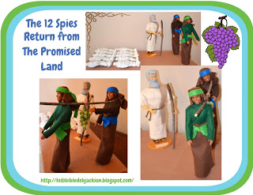

SONGS AND FINGERPLAYS:

10 Were Bad, 2 Were Good
Author: Unknown*
(For Tune see LeAnn Jones or check out this youtube video: Note: Please do not show music videos w/instrumental music during class time. Watch at home to learn the tune and present acapella in the classroom)

Twelve men went to spy on Cannan,
Ten were bad, two were good.
What did those men see in Canaan?
Ten were bad, two were good

Some saw giants big and tall,
Some saw grapes in clusters fall.
Some saw God was in it all.
Ten were bad, two were good.

SUNDAY
LEARNING CENTERS AND ACTIVITIES:
- Have magnifying glasses for the children to examine a few small objects. Then hide those objects in the room. Ask the children to pretend to be spies, and to look for the objects with their magnifying glasses.
- Take home – mini book. Refer to biblestoryprintables.com/TutorialBibleminibooks.html for folding instructions

WEDNESDAY NIGHT
POINTS TO EMPHASIZE:
- Review Sunday’s lesson. briefly (See Review Questions for example questions.)
LEARNING CENTERS AND ACTIVITIES:

Grape Cluster Review Game – Write review questions on the back of purple cardstock circles. Arrange the circles like a big bunch of grapes. Let the students pick a grape. If they answer the question correctly, they get to keep the grape. The student with the most grapes wins, or the class wins when all the grapes have been picked.

Review Story with small toys – Lead the children in acting out the story with Little people or action figures.
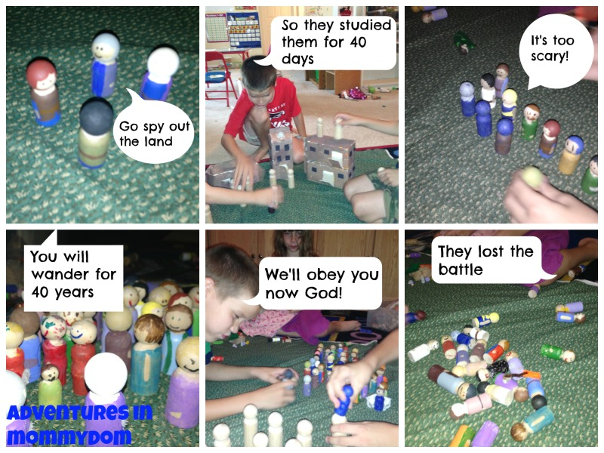

Review Questions

1. How many spies were sent out from each tribe?
- One

2. How many spies were there in all?
a. 12

3. What was the name of the land they were to scout?
a. Canaan

4. What did the spies find out about Canaanites?
a. That they were big, strong, and that there were many people in the cities of Canaan

5. What did the spies bring back from the cities?
a. Pomegranates, figs, and a huge cluster of grapes

6. How long were the spies in the land of Canaan?
a. 40 days

7. What kind of report did the spies have?
a. Ten spies said that the people were like giants and that the Israelites could not defeat them, but two said that they could conquer the land with God’s help.

8. Who were the two spies that gave a good report?
a. Joshua and Caleb

9. How did God punish the people for their lack of faith?
a. He made them wander in the wilderness for 40 years, not letting them go into the Promised Land.

Additional Notes / Activities Performed & Curriculum Feed Back

__________________________________________________________________________________________________________________________________________________________________________________________________________________________________________________________________________________________________________________________________________________________________________________________________________________________________________________________________________________________________________________________________________________________________________________________________________________________________________________________________________________________________________________________________________________________________________________________________________________________________________________________________________________________________________________

